**Singleton C of E School**



**Junior Leadership team**

Our School Vision 

“Passion for Learning and Passion for Life”

“With God all things are possible” Matthew 19:26

“I have come so that they may have life and have it to the full” John 10:10

To provide the children with a wide variety of engaging and challenging opportunities enabling them to live life to the full. Developing a growth mind-set, believing that with God everything is possible. To show, love, trust, wisdom and respect, becoming exemplary role models in our community and the wider world.

Our Christian Values

Respect

Friendship

Endurance

Wisdom

Love

Trust

**For our children we value and promote**

**Happiness**

Those who are happy are great learners.

**Confidence**

Those who are confident always “have a go”.

**Creativity**

Those who are creative can think and learn in imaginative ways.

**Challenge**

Those who are challenged are engaged.

**Perseverance**

Those who persevere have positive outlooks and have self-belief.

**Respect.**

Those who are respectful can see things through the eyes of others



Every year the teachers in your school write a School Improvement Plan- this plan outlines all the things that we need to do to make our school the best it can be. As member of the Junior Leadership Team you will play a significant role in – helping the staff and the governors improve our school

As a member of the Junior Leadership Team you will act as a link between the children in our school and the Head teacher, teachers and Governors of our school.

The Pupil Leadership team members have a vital and special role in making sure that all the children in our school are listened to and have a voice about how they want our school to be and that their ideas are carefully considered.

You will have to make sure that everybody is doing everything that they can to make our school the best it can be. You will share some of the highest responsibilities within our school and will be trained to act as role models of excellence.

**Leadership Roles and Responsibilities**

|  |  |  |  |
| --- | --- | --- | --- |
| **Pupil Leadership role** | **Staff member - link** | **Governors Committee - link** | **Role and responsibilities** |
| Christian Leaders |  |  |  |
| **Reflective Christian Leaders**  (from Y1 – 6)  Up to 12 children | Mrs Rund |  | * Leading Worship * Developing reflection around school * Upholding the Christian Values * Raising money for Charity * Links with Church and Community |
| Learning lead R.E.  2 children | Mrs Rund  2 meetings a term | Standards and Effectiveness committee  1 meeting a term | * Working with staff on the School improvement Plan * Monitoring progress on the school improvement plan * Feeding back to Governors – ideas / findings / opinions etc. |
| **Learning Leaders** |  |  |  |
| Learning lead Literacy  2 children | Mrs Millward  2 meetings a term | Standards and Effectiveness committee  1 meeting a term | * Working with staff on the School improvement Plan * Monitoring progress on the school improvement plan * Feeding back to Governors – ideas / findings / opinions etc. * Run assemblies |
| Learning lead Numeracy  2 children | Mrs James  2 meetings a term | Standards and Effectiveness committee  1 meeting a term | * Working with staff on the School improvement Plan * Monitoring progress on the school improvement plan * Feeding back to Governors – ideas / findings / opinions etc. * Run assemblies |
| Learning lead Science / STEM  2 children | Mr Hogg  2 meetings a term | Standards and Effectiveness committee  1 meeting a term | * Working with staff on the School improvement Plan * Monitoring progress on the school improvement plan * Feeding back to Governors – ideas / findings / opinions etc. |
| Pastoral Leaders | | | |
| Play / friendship support Leader  2 children | Miss Manns | Support daily on the playground at lunch time | * Developing play on the playground * Running games * Encouraging children to play appropriate games * Ensuring that all children have someone to play with * Teaching other children to run games fairly Supporting other children with friendship issues * Working alongside Miss Dolphin to support the development of effective friendships * Worry box issues * Lead assemblies * Supporting other children with friendship issues * Working alongside Miss Dolphin to support the development of effective friendships * Worry box issues * Lead assemblies |
| Growth Mind-set Leaders  2 children | Mrs Rund | Support weekly in Mrs Rund’s Assembly | * Lead weekly assemblies * Promote Growth Mind-set across school * Support with behaviour |
| Internet Safety Leaders | | | |
| Digital Leaders  2 children | Mrs James | Governance Committee | * Vital role in school ensuring the safety of peers when using technologies * Role models of excellent for internet safety – both in and out of school * Share how to use equipment safely * Help prioritise ICT spending * Check equipment stored correctly * Lead assemblies on – keeping safe online * Lead Parent workshops – about on line safety and particularly social media * Lead workshops for other children on online safety – research outside agencies that could help * Plan the internet safety day with staff * Meet with Internet safety governor each half term * Feed back to the Governance committee * Run assemblies |
| Sporting Leaders | | | |
| House Leaders  2 children | Mrs James  Mrs Manns | Resource Committee | * Development of exercise and Fitness opportunities at Break times * Lead houses on sports day * Organise extra-curricular sporting activities with Mrs James * Help decide which competitions to enter each year * Help Mrs James / Miss Manns decide what the allocated Sports Grant money should be spent on to promote fitness and exercise at breaks * Feedback on Sporting events during assembly |
| Health and Safety Leaders | | | |
| Safeguarding, Health and Safety Leaders  2 children | Mrs Clayton | SHE Committee | * Monthly H&S checks / monitoring around school * Monitor the visitors in school – are they identifiable – do all children know what to do if they don’t know who someone is? * Development of the school premises – help prioritise spending * Feedback to SHE Committee * Is the playground secure and safe? * Is the school secure and safe? * Do children know what to do if they are worried or concerned * Are children taught about Safeguarding issues effectively – do they know how to keep themselves safe. * Are there adequate posters around school to support children * Update safeguarding displays |

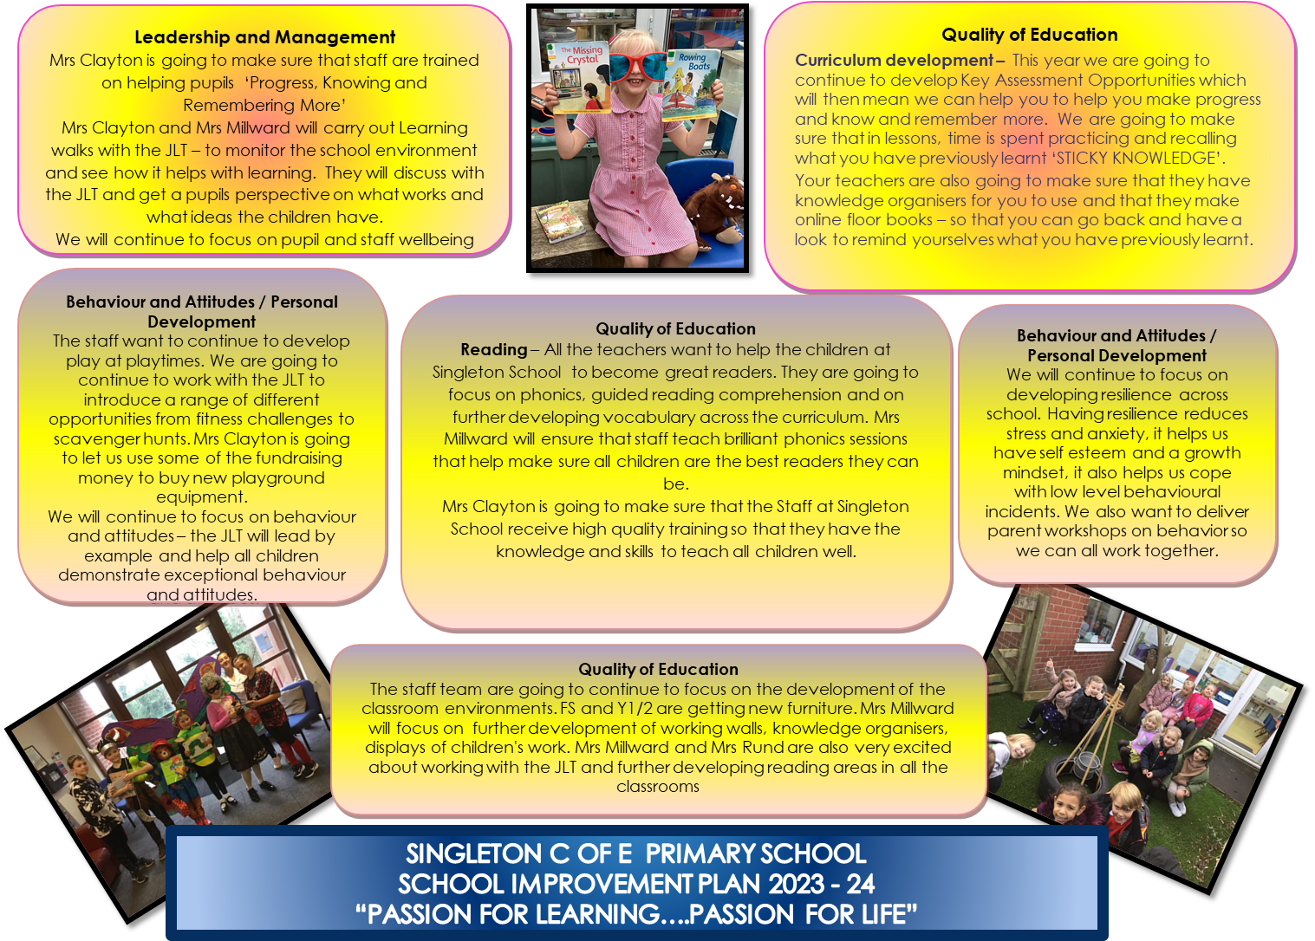

**Singleton Leadership team**

**Governors**

**All our Support team**

**Reflective Christian Leaders**

**Pastoral Leaders**

**Learning**

**Leaders**

**Internet Safety Leaders**

**Safeguarding**

**Leaders**

**Sporting Leaders**

**Pupil Leaderhip team**