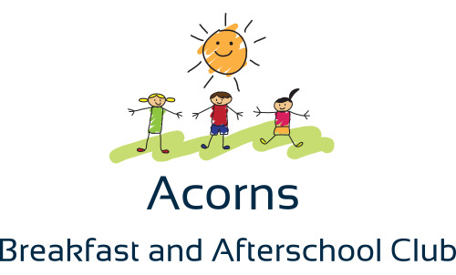

Welcome to Acorns
We provide an affordable and exciting Ofsted registered breakfast and after school club for children at Singleton Primary School. The club is currently held in the Old School Hall. We also use all the outdoors areas as well. Collection and drop-off are from the main entrance. There is plenty of entertainment for both young and older children, including games consoles, games, TV, small world, arts and crafts, sports or just time to relax. We have adult led activities at each session, such as baking, crafts, group activities and many more.
Acorns also run an exciting holiday club in the Easter and Summer holidays (first two 2 weeks only), based at Hambleton Primary Academy.
PLEASE NOTE ONE OFF SESSIONS ARE AVAILABLE!
Important Information:
Staff are trained in paediatric first aid and have regular safeguarding training. We can offer the club sessions on a regular and one-off basis, although sessions will need to be booked in advance. Bookings close at 7p.m the evening before. Acorns is owned by myself, Sarah Goldie, a fully qualified teacher of 20 years. There is a charge for the club and full details of which can be found below:
Session | Fee
The Breakfast Session | £5.00 from 7:30-8:40a.m | A selection of breakfast cereals, toast, pancakes, brioche, croissants, crumpets, fresh fruit, milk and water are available for the breakfast session.
The After School Session  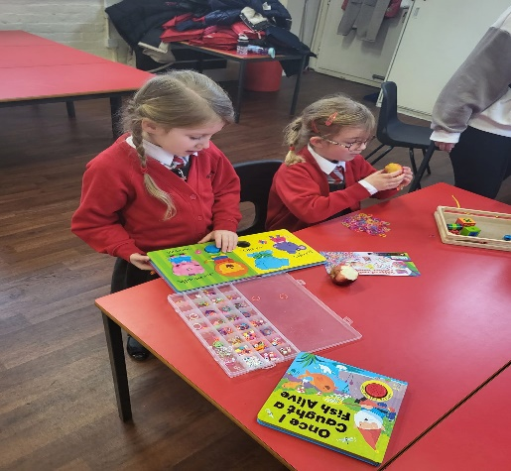 | £4.75 from 3:15-4:15p.m no snack  £5.25 from 4:15 – 5:30pm including snack  £9.75 from 3:15-5:30p.m including snack  These times are set up to work around the various clubs run by school and it is easy to select your choice on the booking website. | Children are given a choice of three different snacks, one of which we encourage to be a piece of fruit. Some examples of the choices are:  Fruit, raisins, mini cheeses, crackers, rice cakes, yoghurts, bagels, breadsticks, toast, potato cakes, Soreen.  The snack choices vary weekly.  A selection of fresh fruit and vegetables are served with all snacks. Milk and water are available throughout the session.

We offer a 10% discount for siblings. This will automatically be deducted upon booking.
For any further enquiries, my contact details are as follows:
TEL: 07860816175 EMAIL: sarahgoldie_uk@outlook.com
If you are interested in booking a place for your child at Acorns, please sign to Kids Club HQ. The link is below or on the school website (follow the Acorns link ) and we have a Facebook page https://www.facebook.com/AcornsSingleton
https://acornsbreakfastandafterschoolclub.kidsclubhq.co.uk/rdr?u=home

