Lesson 1:
Research:
Use the links below to research Anning, Darwin and Wallace. You might want to complete your own additional research too!
Research starting points – NHM links • Mary Anning, Natural History Museum
http://web.archive.org/web/20150503022220/http:/www.nhm.ac.uk/nature-online/science-of-natural-history/biographies/mary-anning/index.html
• Charles Darwin, Natural History Museum
http://web.archive.org/web/20150421031759/http:/www.nhm.ac.uk/nature-online/science-of-natural-history/biographies/charles-darwin/index.html
• Alfred Russel Wallace, Natural History Museum
http://web.archive.org/web/20150425013333/http:/www.nhm.ac.uk/nature-online/science-of-natural-history/biographies/wallace/index.html
Task:
Complete the three fact file tables (see lesson 1 resource pack) about Anning, Darwin and Wallace:
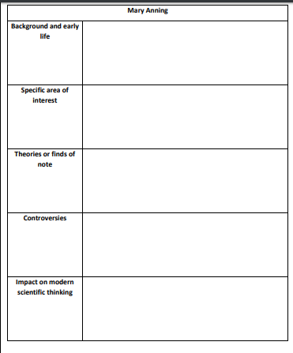

Lesson 2
Complete ONE of the below challenge cards:

Challenge Card 1 (see lesson 2 resources for fossil pictures)
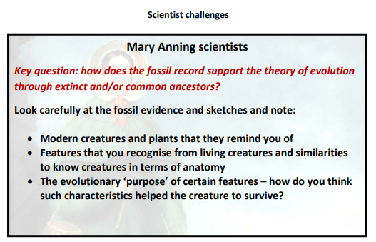

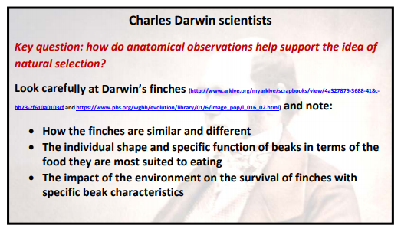
https://www.pbs.org/wgbh/evolution/library/01/6/image_pop/l_016_02.html

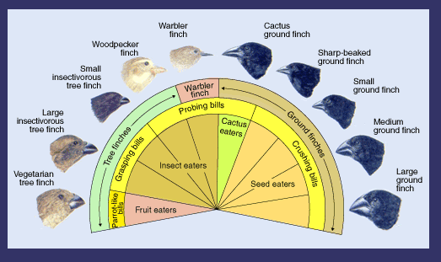

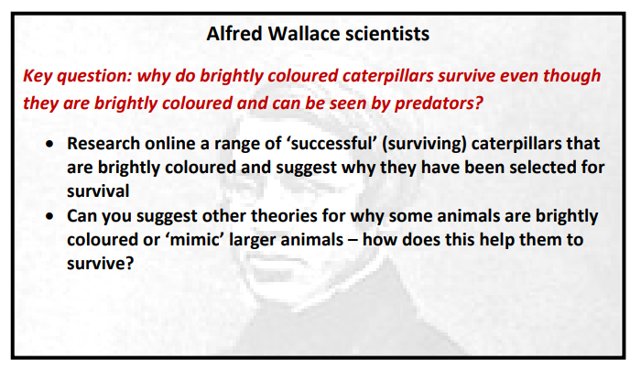

Lesson 3:

Research:

Read through ‘Theory of Evolution ‘PowerPoint

Task:

