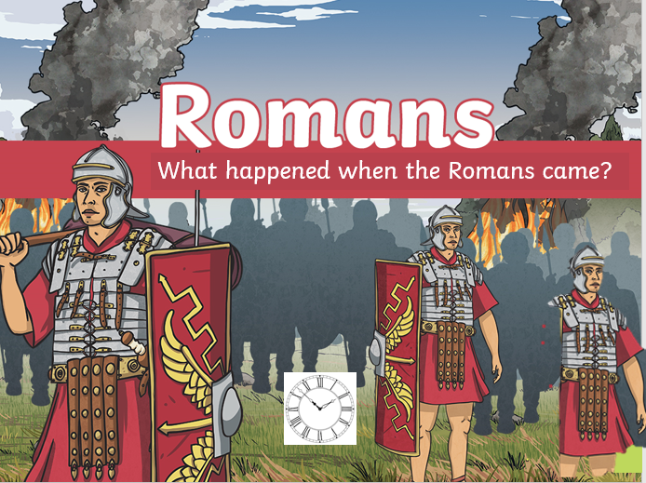

Hi Class 2,

As you enjoyed the Roman History topic so much, we are going to continue and develop on what you’ve learnt for your Summer Term 1 work! I’m going to outline the work below and there will be a corresponding folder with work/support material attached. Each Task is intended as one week’s work (therefore one task per week)
You will be, over the course of the topic, looking at the impact the Roman empire had on life in Britain. You have already learnt about the spread of the Roman empire, the invasion of Britain and the eventual conquest but are now also going to look at what a Roman soldier might have looked like! You will also look in detail at some aspects of the Romanisation of Britain, such as the building of Roman roads and bathhouses. In addition to this, you will learn about the British resistance of Boudicca and will act in role to look at the events of Boudicca's rebellion from different perspectives. You will also investigate Hadrian's Wall, examining how, where and why it was built. This will include looking at the different features of the wall and use maps to determine its location. A lesson on gods and Roman religion will help you understand more about the culture and beliefs of Roman people, and you will play and design games to consolidate your knowledge about the different Roman Gods and Goddesses.
I hope you enjoy finding out even more about the Romans!

Miss you lots,

Mrs Marshall

Task 1 (week 1)= ROMAN SOLDIERS!
Activity 1: Label a Roman Soldier and design a Roman Shield.
Could you design your own shield using coloured card and/or paint?!
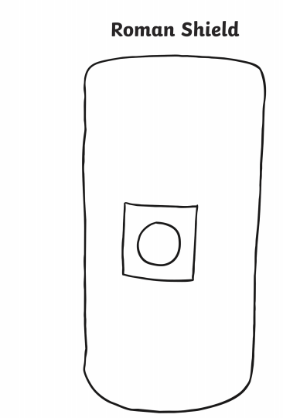
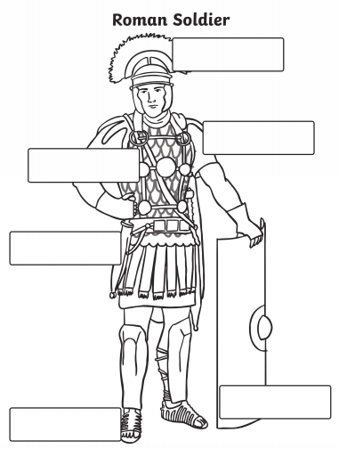

Extension: Make a 3-D model of a Roman Soldier!
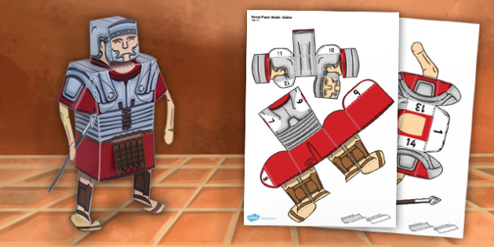

Task 2 (week 2)= MOSAICS!
Roman Homes- starting with mosaics!
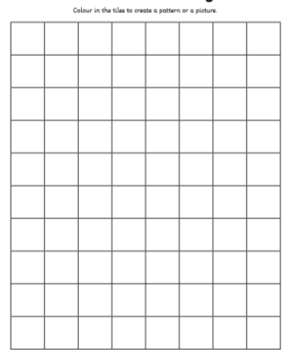
Create your own mosaic pattern like you would have found in many wealthy Roman homes! You could even cut out fabric/collage material (like tissue and coloured paper) to create even more unique designs!
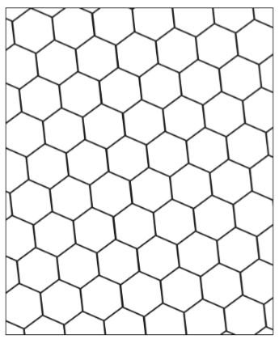

Task 3 (week 3)= Boudicca’s Rebellion!
Activity 1:
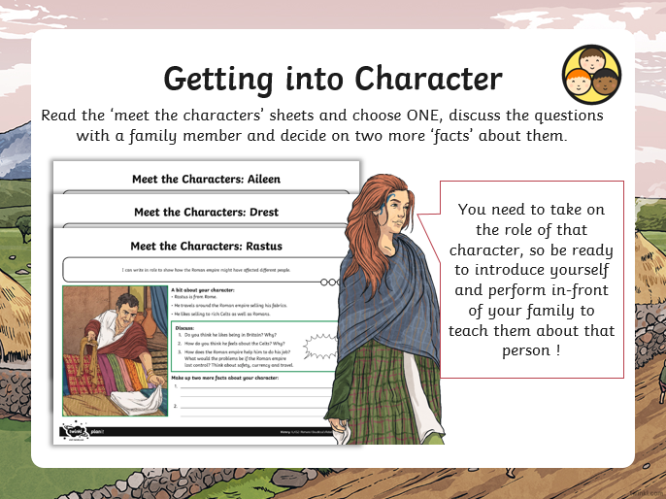

Activity 2:

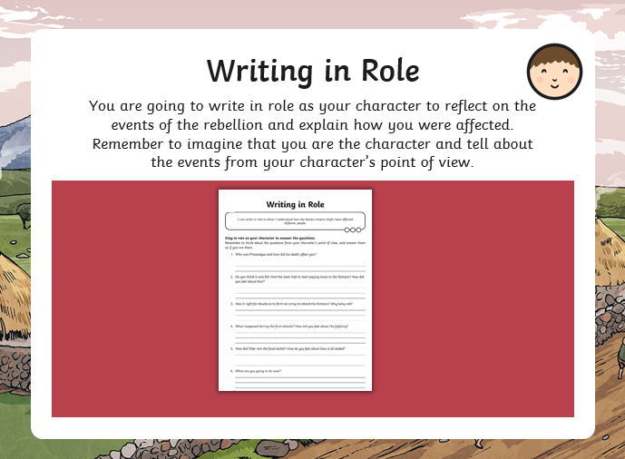

Task 4 (week 4)= Hadrian’s Wall
Activity One:
- Use Google Maps (or an atlas if you have one) to find some of these places on your map.
- Can you find out the names of some other places that the wall passed through? What counties are they in? What else can you find out about them?
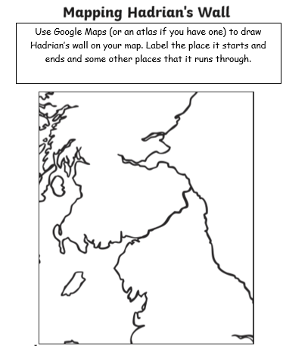
- Label your own map to show Hadrian’s Wall and some of the places it ran through.

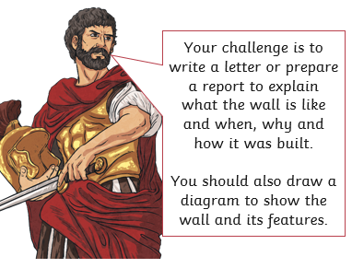
Activity Two:
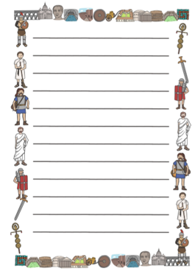

Task 5 (week 5)= GODS & GODESSES
Choose ONE game (can play more than one if you’d like) and have fun with family/guardians whilst finding out about Gods and Godesses!
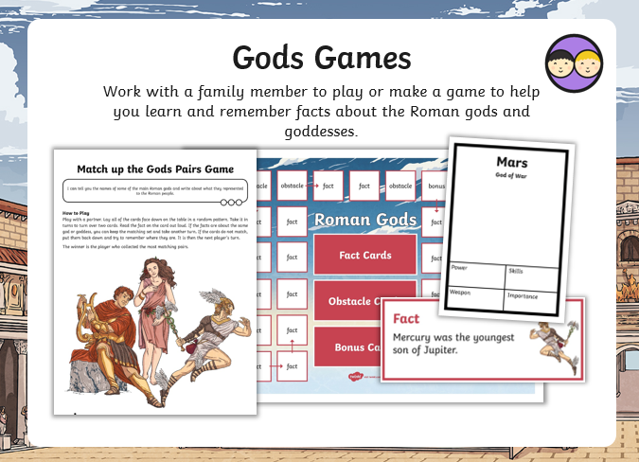

Task 6 (week 6)= ROMAN HOUSES
Create an advert for a Roman Home for Sale. You’re the ‘persuasive features’ power-point to help you! Also have a look on https://www.rightmove.co.uk/ and look at these language features being used in real life!
