PRINTING
Over the next few weeks I’d like you to explore different printing techniques. Don’t forget to let us know how you’re getting on by sending your photos through Singleton School Facebook Messenger or to terrianne.manning@singleton.lancs.sch.uk

Week 1 | Potato printing…  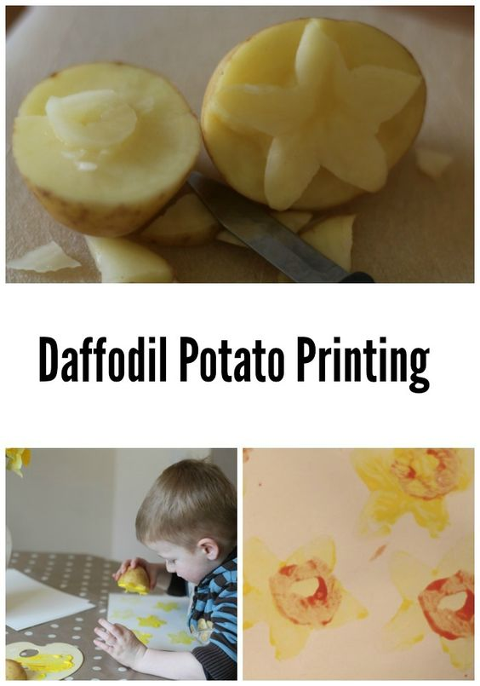
Week 2 | Bubble wrap printing…  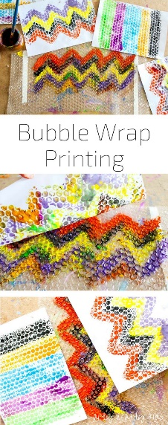
Week 3 | Leaf printing…  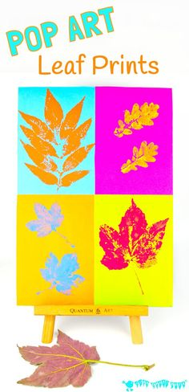
Week 4 | Different things found around the house…  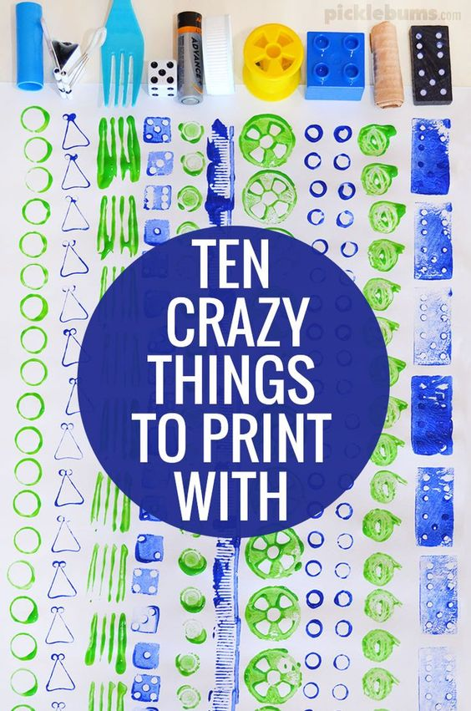
Week 5 | Rubber bands…  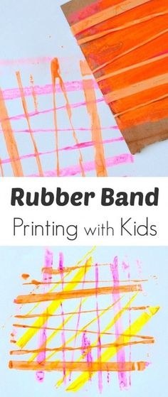
Week 6 | Polystyrene foam…  