Weather Balloon
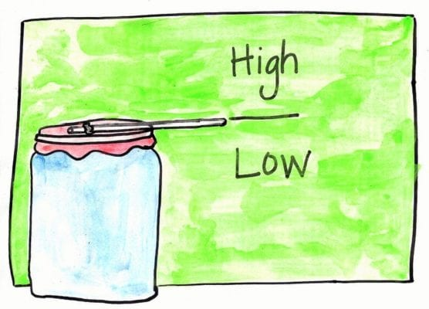
Materials Needed
- A glass jar
- A balloon
- A piece of paper.
- Sticky tape Straw
- Pen Scissors (adult supervision)

The Brief
Make a barometer and predict the weather.

Method
Cut the bottom half off a balloon.
Pull the top half of the balloon tight over a jam jar.
Use the elastic band to keep the balloon tight over the jar.
Fix the straw to the centre of the balloon skin using a piece of sticky tape.
Place the paper so it is lined up against the straw. Draw a line at this position.
Above the line write the word ‘High’ and below the line write the word ‘Low’
Note down the pressure high/low each day to see if you can notice a pattern between your air pressure readings and the weather outside.

Record your results and see if these are affected by the weather outside.
Write a paragraph explaining what you noticed; you will need to research air pressure and barometers.
Do not forget to take a picture or two of your contraption!

