UKS2: Topic: Ancient Greece Block H: Education Session 4
How to make a great Greek thinker
Here are some Great Greek Thinkers:
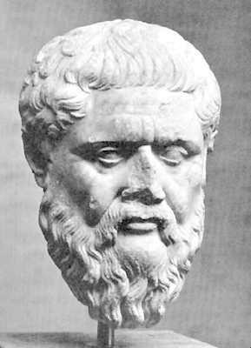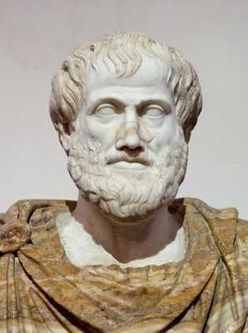
Plato
Aristotle
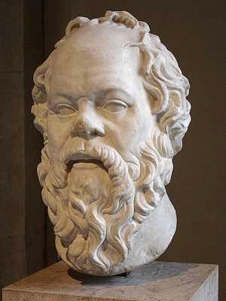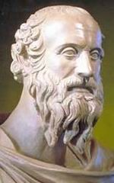
Socrates
Diogenes
Continue to find out how to make one out of clay!
© Original resource copyright Hamilton Trust, who give permission for it to be adapted as wished by individual users. We refer you to our warning, at the foot of the block overview, about links to other websites.
To make Plato, you will need:
Air drying clay, Clay tools Clay board.
Take the clay and separate into several balls. Have one larger lump of clay for the head. Roll this into an oval and stand it on the table or clay board.
Pinch the clay where you want the nose to be. Mould the clay into a nose shape.
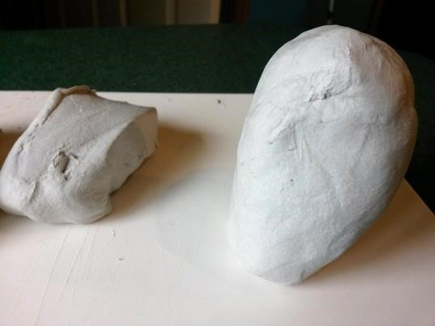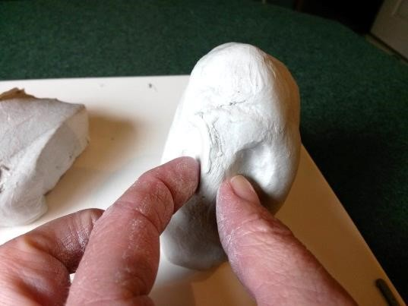
Use your finger or clay tool to shape the nose and nostrils. Keep looking closely at the picture of your Greek Thinker. Shape the eye brows in the same way.
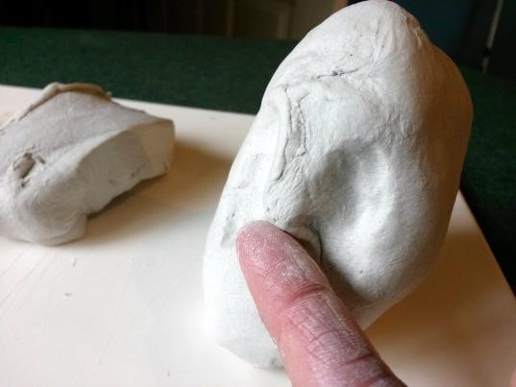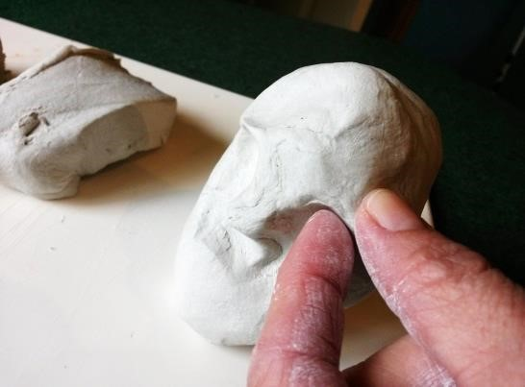
The key to making a Greek Thinker look like a Greek Thinker is the hair. Lots of the Greek Thinkers had long curly hair and beards. Roll the clay into thin sausages.
When you have enough, roll the ends up into curls and stick them into the right places for a beard, moustache and hair.
You may need to help them to stick by making clay ‘glue’. Do this by popping a bit of clay into a little pot with some water and mixing together to make a sort of sludge. Dip your finger in this and rub onto the areas you want to ‘glue’ together.
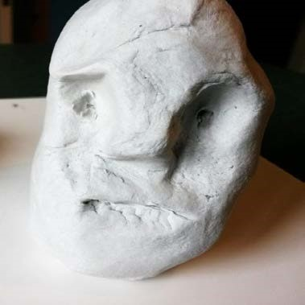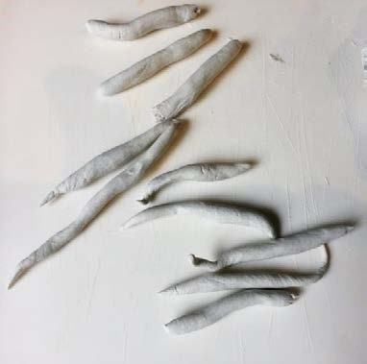
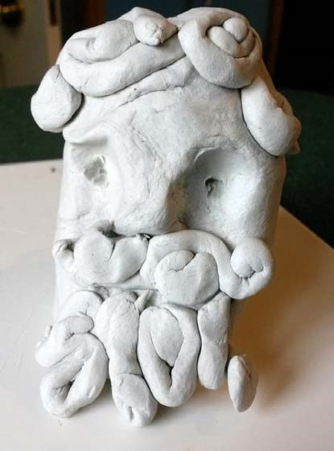

Here are some links to help you with your mini biographies.
Horrible Histories Ancient Greek thinkers song from vimeo.com
Lyrics to the Horrible Histories on Ancient Greek thinkers from lyricsfreak.com
Education in Ancient Greece from primaryhomeworkhelp.co.uk
Information for children on Ancient Greek thinkers from primaryhomeworkhelp.co.uk
Summary information about 15 great Greek thinkers from listverse.com

