This work is for both Monday and Thursday

This week’s topic will be more ‘hands-on’ - in that the children will be making a couple of commonly used Greek objects. Below are a list of some of the materials that might come in useful although individual initiative might also come in handy! However, if the items cannot be obtained, please create a fact sheet about the items or why not produce their own instructional, ‘How to make’ guide including diagrams.

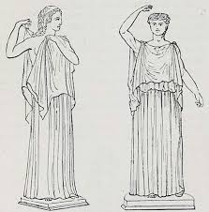
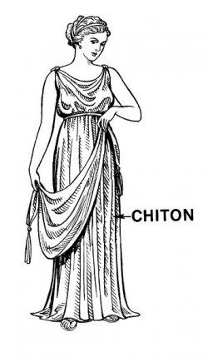
Chiton (Like a toga)
You will need:
A large rectangular piece of fabric (bed sheet)
A large brooch
Safety pins
A thin belt or rope
Gold ribbon or shiny material
Scissors

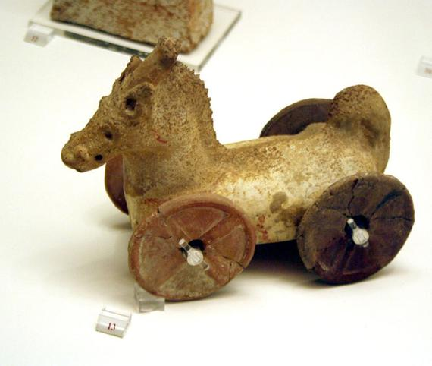
Greek Toy
You will need:
Terracotta air-drying clay. (plasticine will do)
Wooden rod or thin stick. Strong glue.

Sandals
You will need:
A piece of leather or thick material, or a piece of car mat/foam (cardboard will do).
Strong scissors
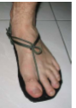
Leather hole punch
Leather strips or strong cord/shoe lace
Paper and felt tips

Thanks
Mr Goostry

