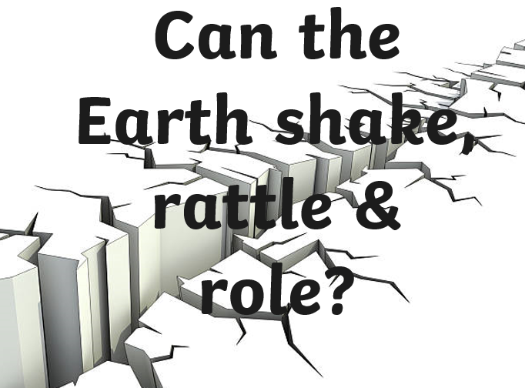

Hi Class 2,

As you enjoyed the Earthquake/Volcano geography topic- ‘Can the Earth, Shake, Rattle and Roll?’ so much, we are going to continue and develop on what you’ve learnt for your Summer Term 2 work! I’m going to outline the work below and there will be a corresponding folder with work/support material attached. Each task is intended as one week’s work (therefore one task per week)
You will be, over the course of the topic, looking at:

- What is happening when the earth rattles and rolls and being able describe what a volcano is/what happens when one erupts and the location volcanoes are found.
- Investing whether the earth shake, rattle and roll all over? Being able to describe the distribution of earthquakes and volcanoes; understand that volcanoes cab be active, dormant and extinct and know about the Pacific ring of fire
- How and why do people live where the earth shakes, rattles and rolls? Being able to describe examples where and know the main reasons why, people live in the vicinity of volcanoes and know the hazards for people who live near earthquake, volcano zones.
- Investigating real volcanoes- volcano art!!
- Create a fact sheet all about volcanoes and earthquakes!
- THE BIG FINISH: Can you make a model volcano that erupts?!

I hope you enjoy finding out even more about Earthquakes and Volcanoes!

Miss you lots,

Mrs Marshall

Task 1 (week 1) = How a Volcano is formed

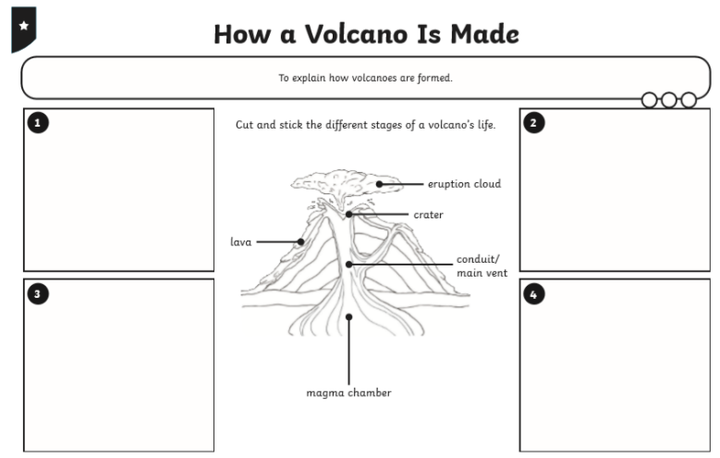
Watch the power-point about volcanos and then complete the ‘How a Volcano is made’ worksheet.

Task 2 (week 2) = Earthquakes

Watch the presentation on earthquakes.
Complete:
Activity 1:
Activity 2:
Design an earthquake-proof building.
Number the different statements from 1-12
Sort them in strength from the least the most powerful.
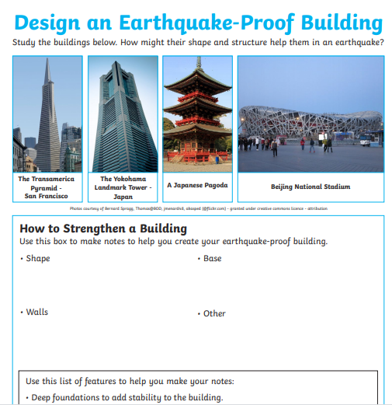
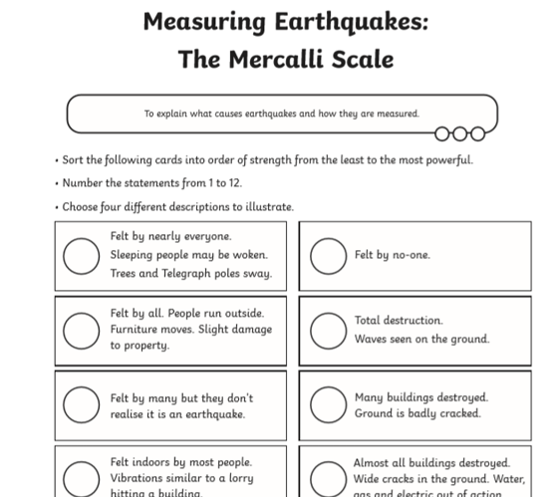

Task 3 (week 3) = Why do people live in volcano areas?

Watch the power-point presentation and then organise the activity cards into ‘for’ and ‘against’ before answering the questions below.
Activity 1:
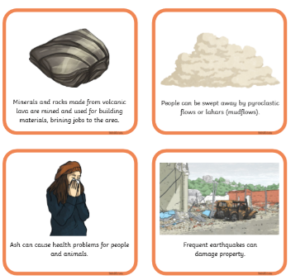
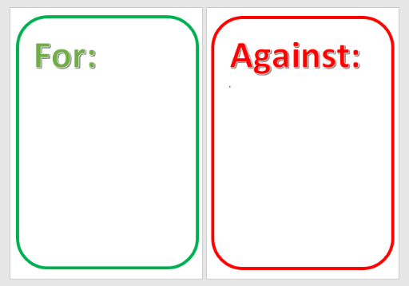

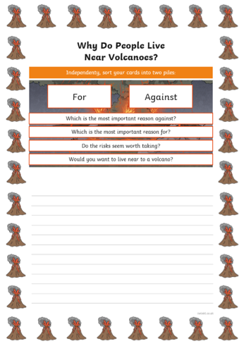
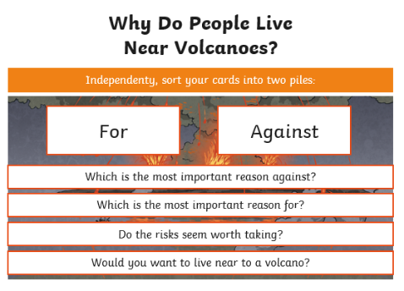
Activity 2:

Task 4 (week 4) = Investigating Volcanoes: Volcano Art!

Watch the videos/look at the image bank and create your own art work to represent a volcanic explosion- you could use paints/pastels/chalks (reds & oranges look brilliant against black paper) and remember if painting you don’t necessarily need to use paint brushes you can use anything- lolly pop sticks/cotton wall balls to print…anything you can get your hands on- the more creative the better! We can wait to see your creations!

https://www.google.com/search?q=volcano+art&sxsrf=ALeKk03gZY236rAo79Y6RRH8uDAr7FkG9g:1590317066743&source=lnms&tbm=isch&sa=X&ved=2ahUKEwiltN_eqMzpAhW1nVwKHTwgCjcQ_AUoAXoECBIQAw&biw=1366&bih=576

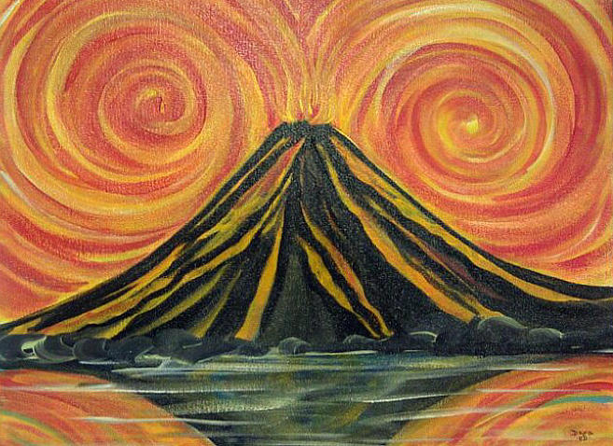
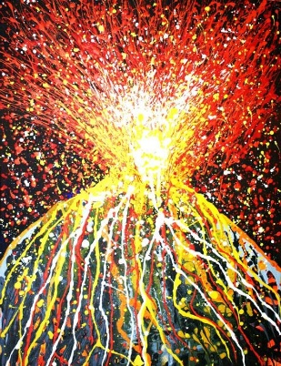
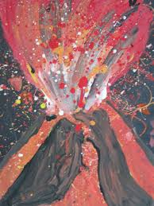

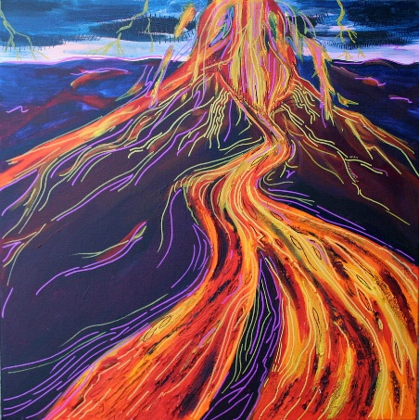
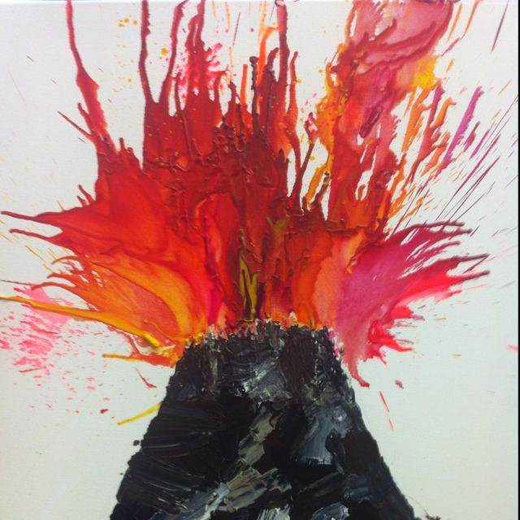
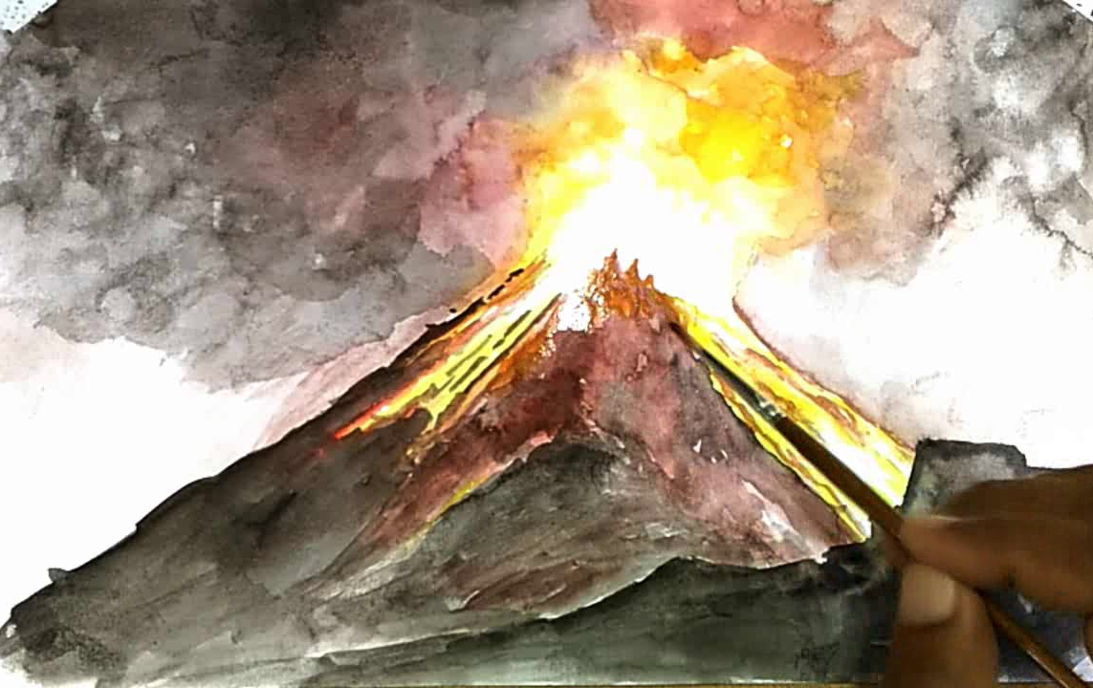

Task 5 (week 5) = Dangerous Volcanoes

Activity 1:
Can you use google maps/an atlas to identify the world’s most dangerous volcanoes?
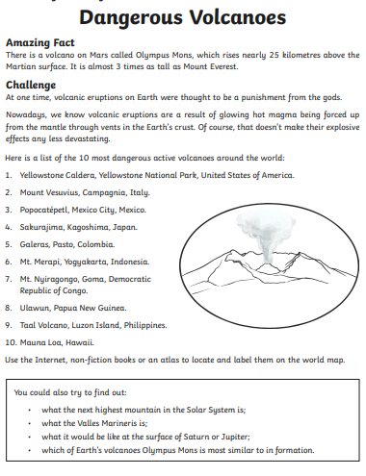
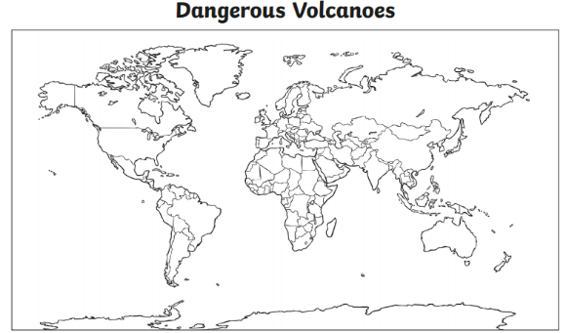

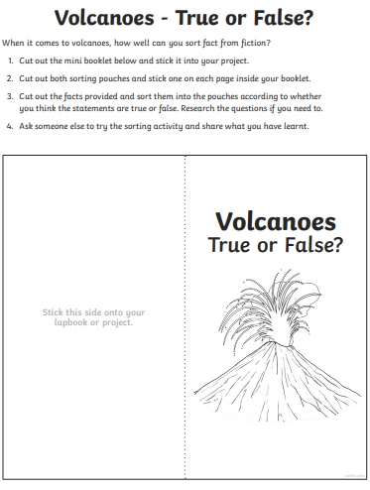
Extension:
Can you cut out the sorting pouches and correctly organise the statements into true or false?!

Task 6 (week 6) = Fact Sheet about volcanoes and earthquakes!

- Create a fact sheet all about volcanoes and earthquakes! You can choose one of the volcanoes on the factsheets to help you or research your own:
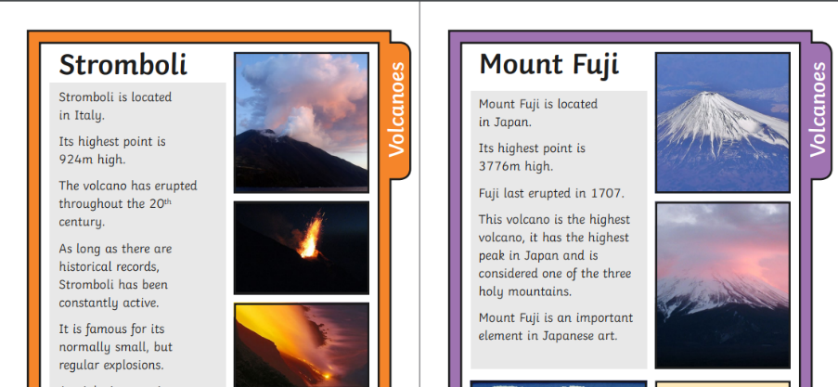
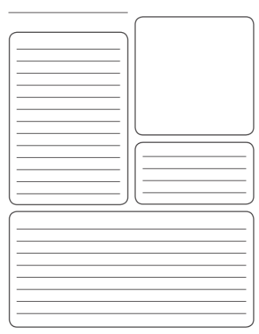

Task 7 (week 7) = Make your own volcano!

Using either clay or paper mache build round a paper cup to make a ‘volcano’ and then follow the instructions below to create the ‘lava’ explosion!
