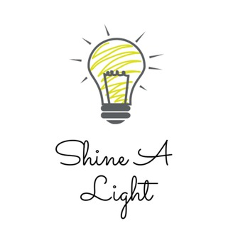

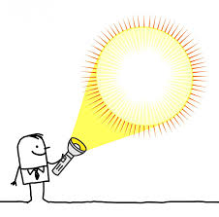

Hi Class 2,

As you enjoyed the science topic- ‘Shine the Light’ so much, we are going to continue and develop on what you’ve learnt for your Summer Term 2 work! I’m going to outline the work below and there will be a corresponding folder with work/support material attached. Each task is intended as one week’s work (therefore one task per week)
You will be, over the course of the topic, looking at:

- Investigating Light and Dark
- Reflective Surfaces
- Marvellous Mirrors
- Sun Safety- UV Light
- Making Shadows
- Changing Shadows
- Shadow STEM activity!

I hope you enjoy finding out even more about Light and Shadow!

Miss you lots,

Mrs M

Task 1 (week 1) = Investigating Light and Dark

Look at the Light and Dark Power-point before completing:
Activity 1:
Can you sort the different items into whether they are a light source or not.
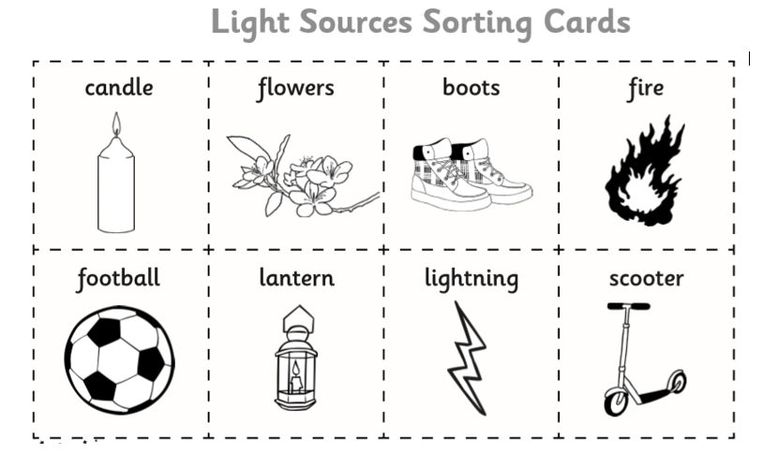
Activity 2:
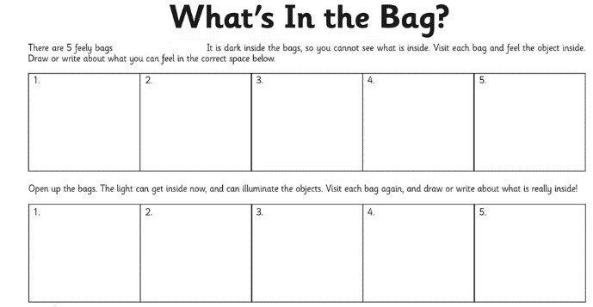
What’s in the bag?! Put six different items in a bag/pillowcase (can be anything that you can’t see through) and complete the following table:

Activity 3:
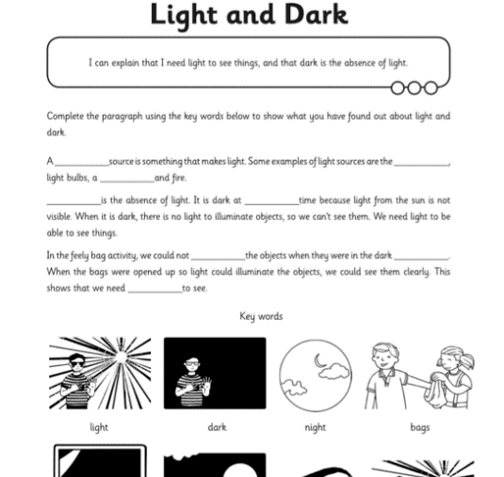
Fill in the gaps using the key words provided:

Task 2 (week 2) = Reflective Surfaces

Look at the Reflective Surfaces Power-point before completing:
Activity 1:
Look around your house (with permission from a parent/guardian) and try and find 6 materials that you think might be reflective!
Fill in the table below: (follow the power-point to help you complete the ‘reflective’ test and then rank the materials in order (from least to most reflective):
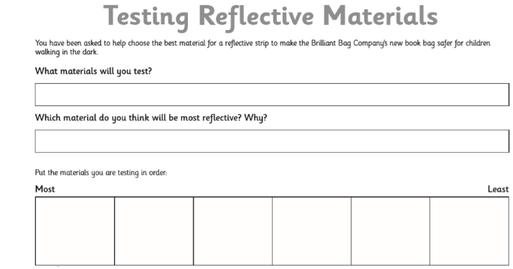

Activity 2:
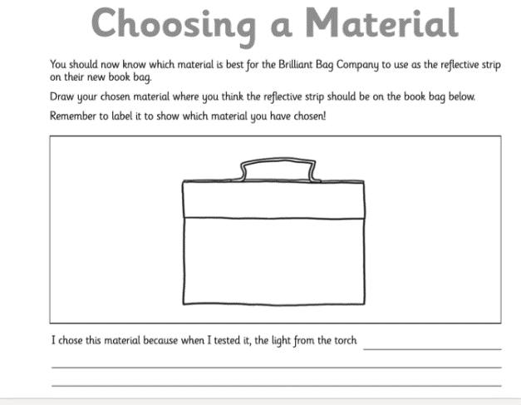

Task 3 (week 3) = Marvellous Mirrors

Look at the Marvellous Mirrors Power-point before completing the following sheet:
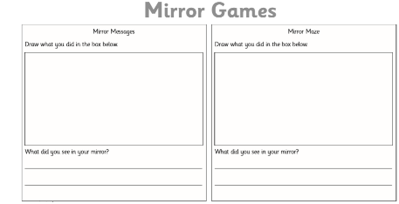

Activity 1: Mirror messages
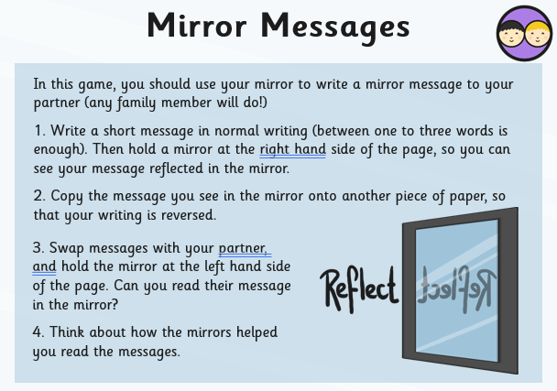

Activity 2: Mirror Maze
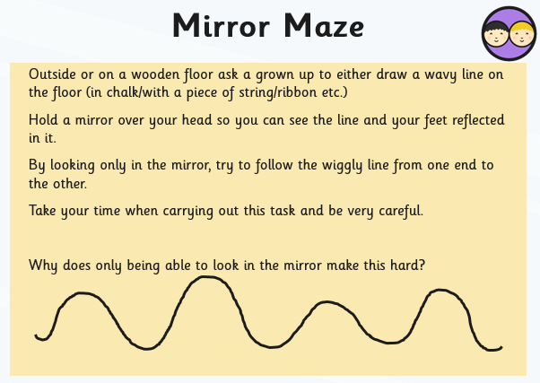

Task 4 (week 4) = Sun Safety- UV Light

Look at the Sun Safety Power-point before completing the following activities:
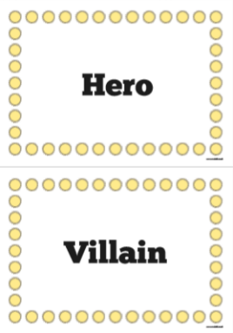
Activity 1:
Read the statements and decide if they go under the ‘hero’ or villain’ category:
Activity 2:
Design either a pair of sunglasses or sun hat to protect people from the sun’s UV Light.

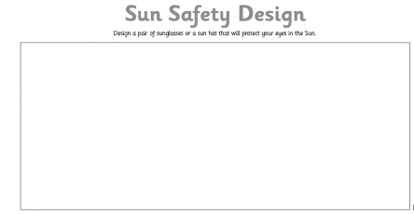

Activity 3:
Design a sun safety advert/poster:
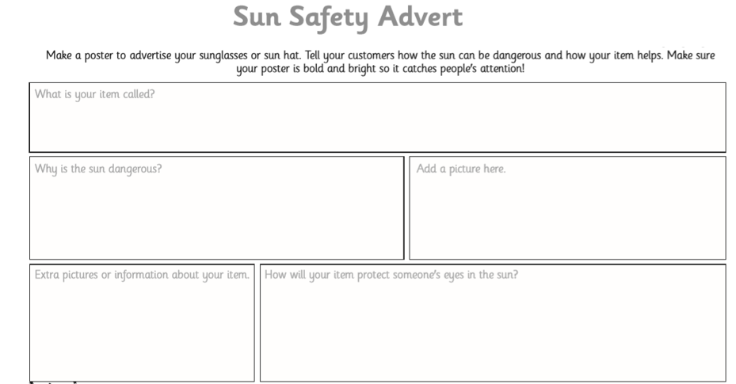

Task 5 (week 5) = Making Shadows

Look at the ‘Making Shadows’ Power-point before completing the following activities:
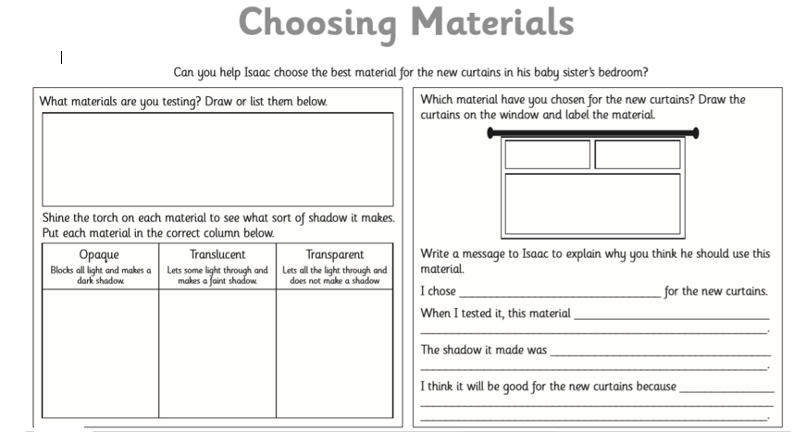

Task 6 (week 6) = Changing Shadows

Look at the ‘Changing Shadows’ Power-point before completing the following activities:
Activity 1: Complete the shadow investigation:
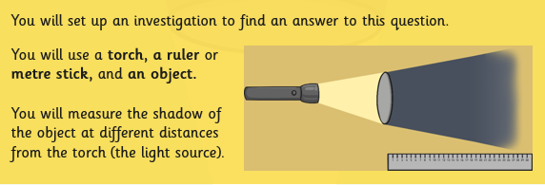

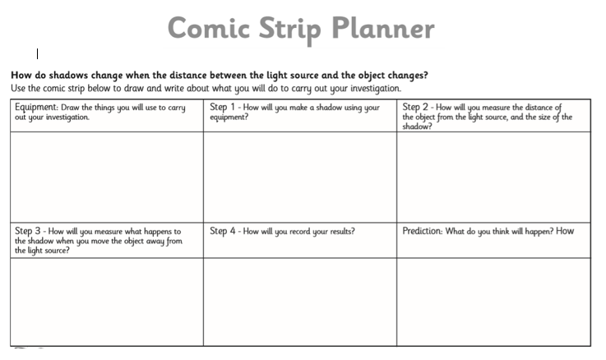
Filling in the investigation planning sheet:

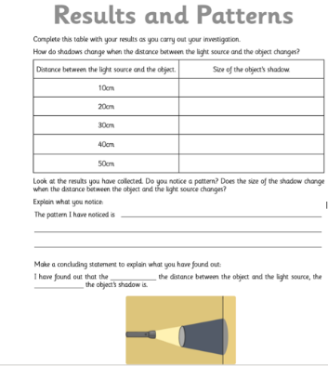
Activity 2:
Complete the results table:

Task 7 (week 7) = Shadow STEM Activity

Look at the ‘Shadow STEM Activity’ Power-point before completing the following activity:
