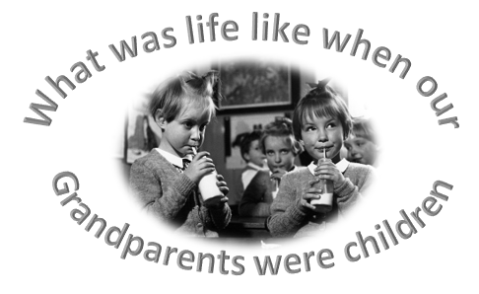

Hi Class 1,

We have got a very exciting history topic this half term! We are going to be investigating what life was like when our grandparents were children! I’m going to outline the work below and there will be a corresponding folder with work/support material attached. Each task is intended as one week’s work (therefore one task per week)

You will be, over the course of the topic, looking at:

- Has childhood always been the same? I can describe school life in Britain in the 1950s/1960s
- Then and Now- comparing household and school items- time to be a researcher!
- Was Grandad’s bedroom like mine? -I can identify features of a typical 1950s home
- Did Grandad have an X-Box?-I can distinguish old toys from new toys.
- How did Granny spend her pocket money?-I can name each pre-decimal coin up to 1 shilling and express its value in terms of one new penny.
- 1950’s music! 1950’s fashion- then and now!
- THE BIG FINISH: Here are our digital scrapbooks!-I can collate digital files about an aspect of 1950s/1960s childhood.

I hope you enjoy finding out about life in the 1950’s/60’s!!

Miss you lots,

Mrs Marshall 😊

Task 1 (week 1) = School Life in the 1950’s/60’s

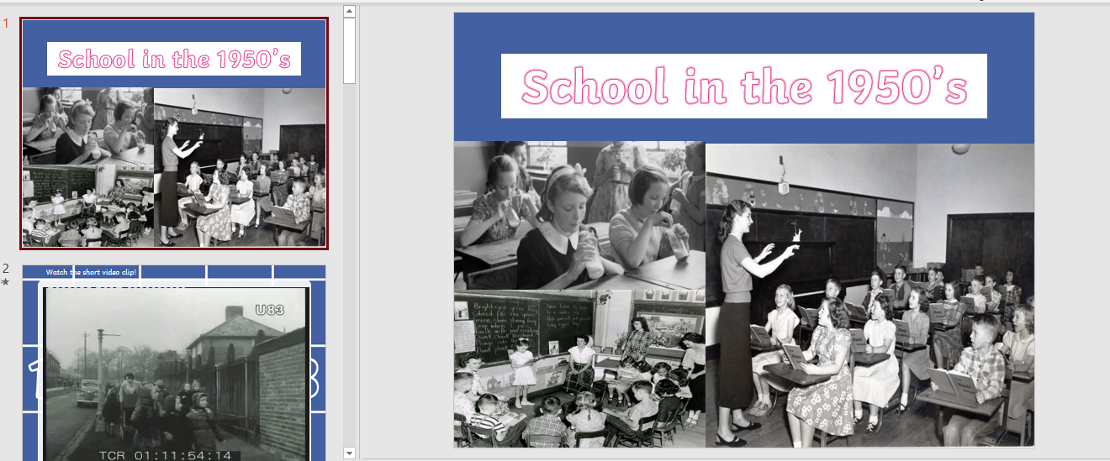Read through the power-point/watch the video below:

Extension: You might also want to look at the following websites:
https://www.historic-uk.com/CultureUK/Schooldays-in-the-1950s-1960s/
http://www.singletontrust.co.uk/ (click on school history)
Our lovely little school was built in 1863 so would have been celebrating it’s 100th anniversary in 1963!!
Activity 1:
Sort the pictures or write words in the Venn diagram using this
comparing school's activity sheet.
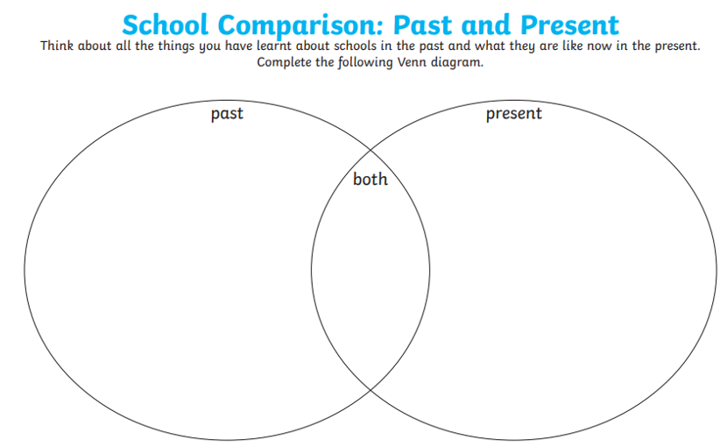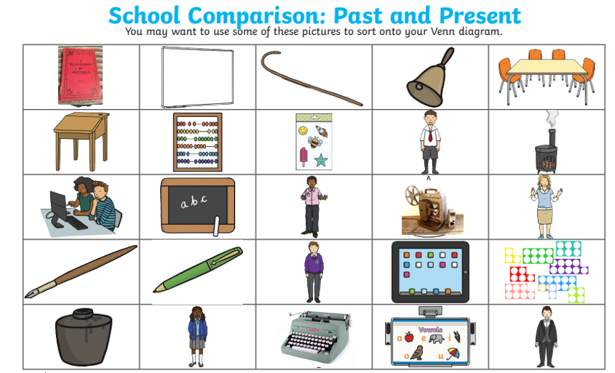

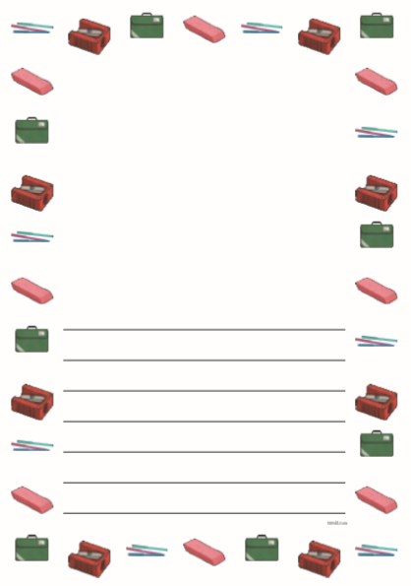Activity 2:
Use the page border writing frame to write about the similarities and differences between schools then and now. Could you write a diary as though you were one of your Grandparents?!

Task 2 (week 2) = Then and Now- comparing household and school items- time to be a researcher!

Your task this week is to be a researcher! Use the internet or even better ring someone who went to school in the 1950’s/60’s and speak to them!
Start by looking at the below power-point:
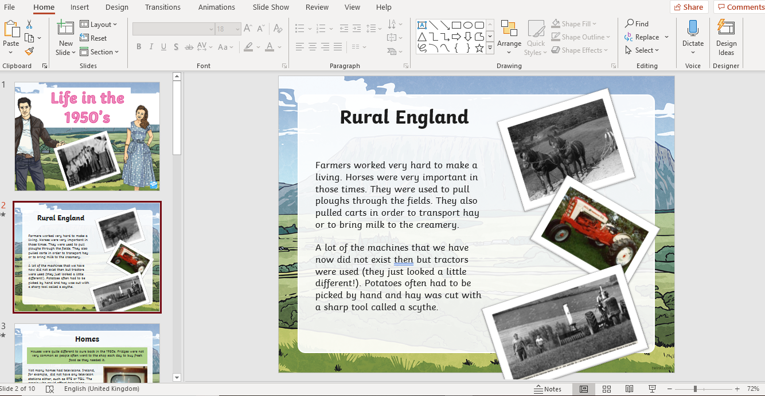

Activity 1:
Complete the research sheet below:
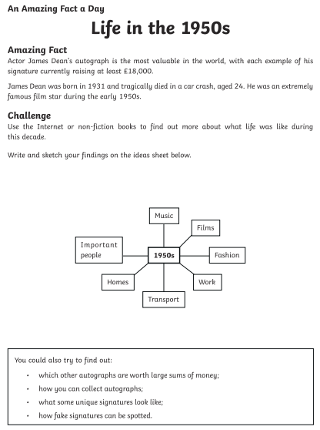

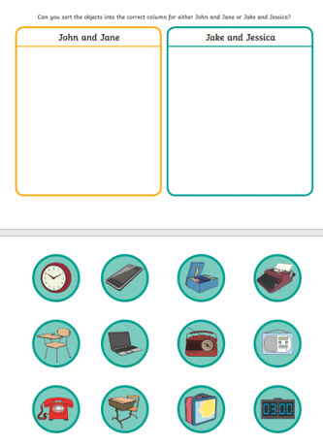Activity 2:
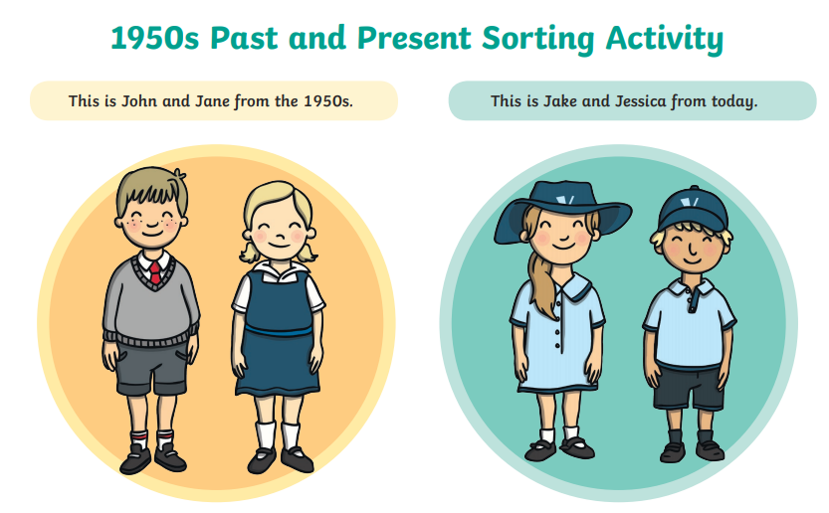Can you organise the different objects into ‘Then and Now’- can you add any more?!

Task 3 (week 3) = Was Grandad’s bedroom like mine? -I can identify features of a typical 1950s home

Go on this BRILLIANT web-page to look at fantastic vintage colours of a 1950’s home!!
https://bigchill.com/us/blog/7-reasons-why-1950s-homes-rocked/
Look through the 1950’s home power-point:
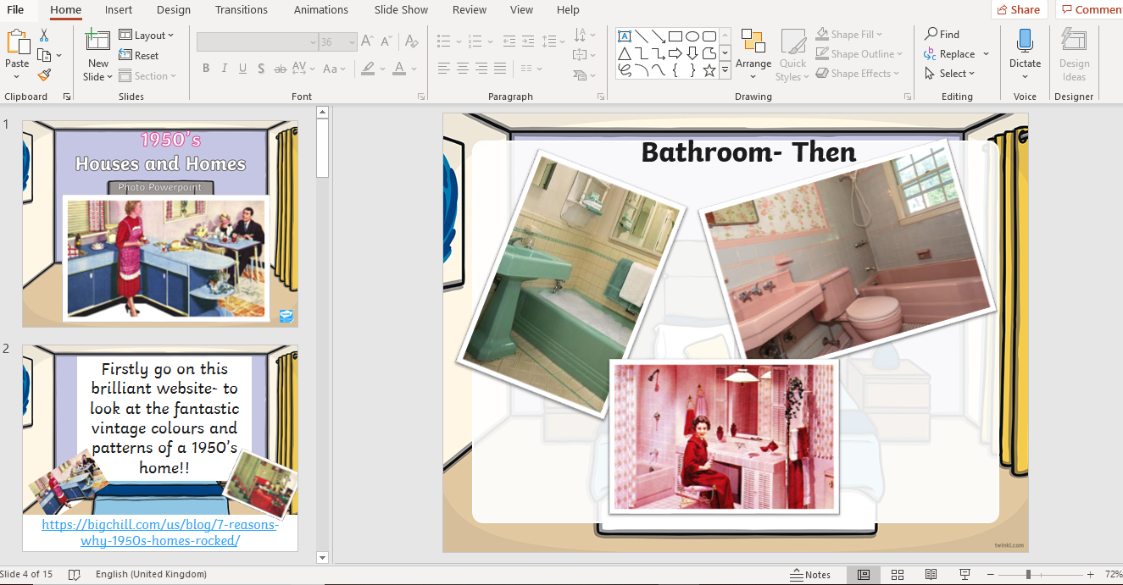
Activity:
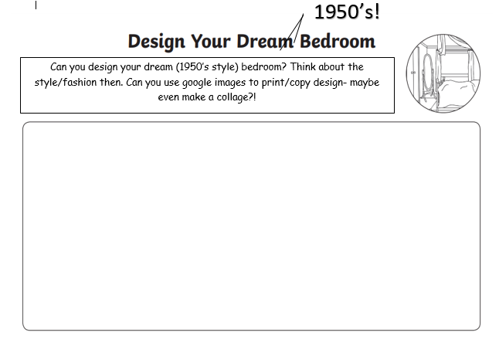Can you design a 1950’s style bedroom? What items would feature? Make sure you label them! Can you use the internet to print/cut out items to make a collage?! What items would you expect to see? What things would not have been available/fashionable then? Have your family got any old pictures you could borrow/share with us as inspiration?!

Task 4 (week 4) = Did Grandad have an X-Box?-I can distinguish old toys from new toys.

Toys are an incredible thing as although technologies change and new toys are invented…and even though, for example, materials used to make them changes, e.g. from metal to plastic etc. You can’t look at toys without looking further back in history as the lovely thing is the teddy you cuddle at night may well not be very dissimilar to what your Grandparents (and Great Grandparents cuddled) and the same goes for crayons/colours you use and even the ‘real world’ dolls/toy soldiers etc- great toys really do stand the test of time!! Take a look at the history of toys poster and the x2 power-points- the second power-point ‘Early 20th Century toys’ has some added images of 1950’s toys that were designed and created during this period- I wonder if you’ve ever played with them?!
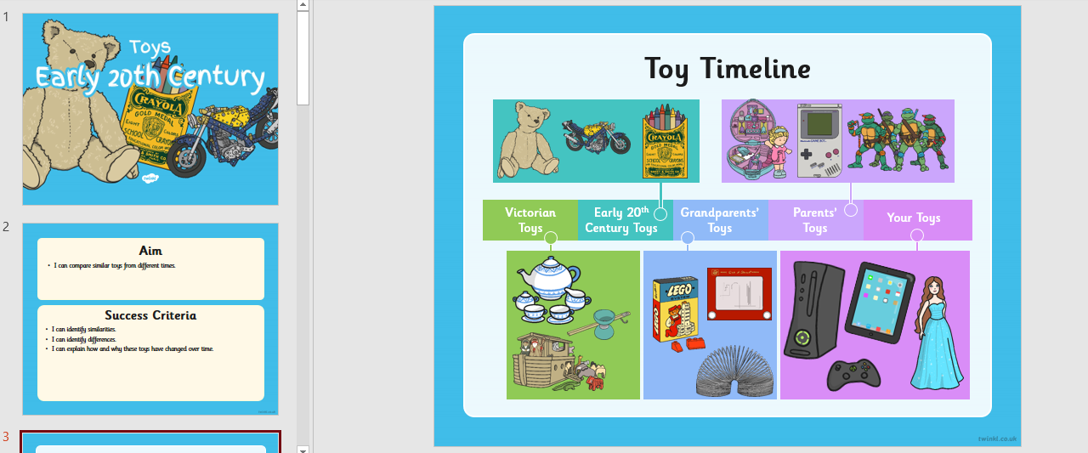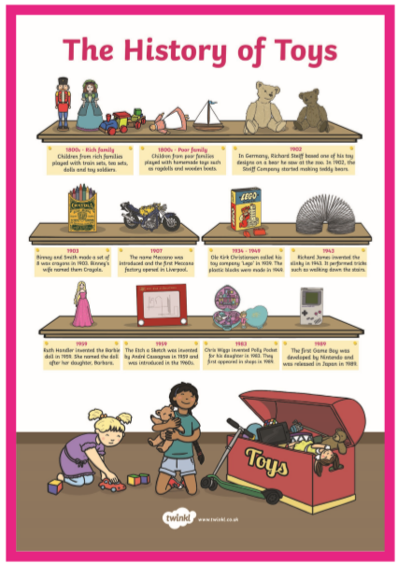

Activity:
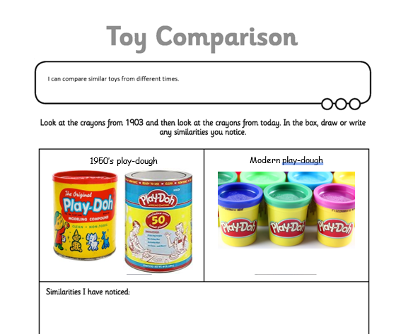

Task 5 (week 5) = How did Granny spend her pocket money?-I can name each pre-decimal coin up to 1 shilling and express its value in terms of one new penny.
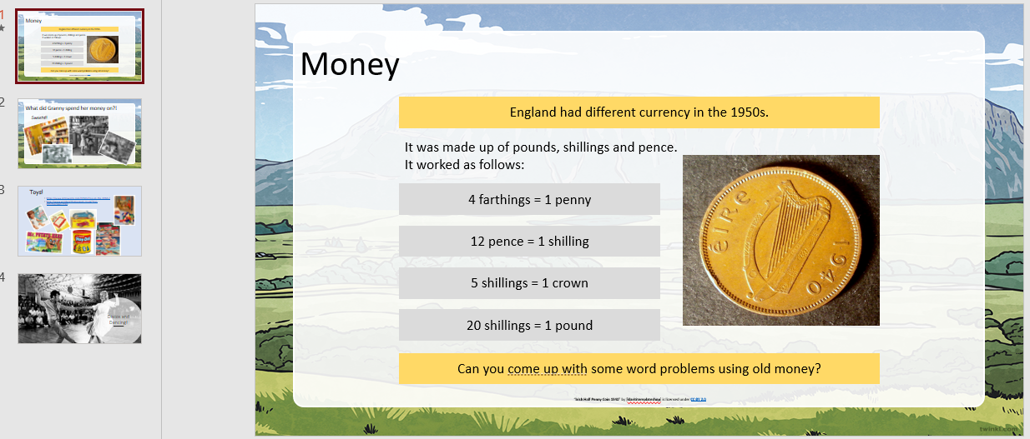

Activity 1:
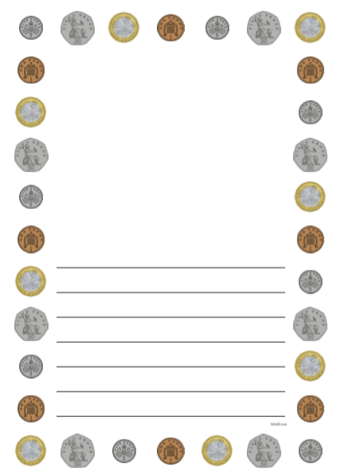Can you come up with your own word problems using old money?!

E.g. If I buy a bag (quarter) of sweets that cost 2 shillings and a toy etcher-sketch that costs 24 shillings- how much have I sent in total?

Task 6 (week 6) = Dance into the 1950’s- Learn the 1950’s Jive!!!

Look at the power-point and task resource and create your won 1950’s inspired dance routine! Have fun and video if you can! Complete the planning sheet to help you remember the routine:
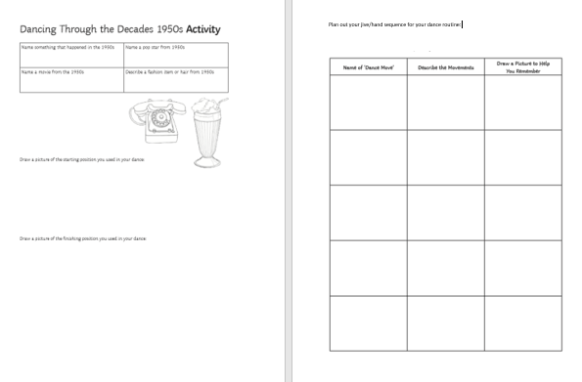

Task 7 (week 7) = THE BIG FINISH: Here are our digital scrapbooks!-I can collate digital files about an aspect of 1950s/1960s childhood.

Choose one aspect of the 1950s/1960s that interests you most and either create a digital scrapbook (collection of images and key facts/details) on power-point/movie-maker software or as a leaflet. If you can interview your own Grandparents/or someone you know who a child during this period was even better- via phone/skype etc.! Have fun and I can’t wait to see your projects!

