Star-Line a new national helpline for parents:
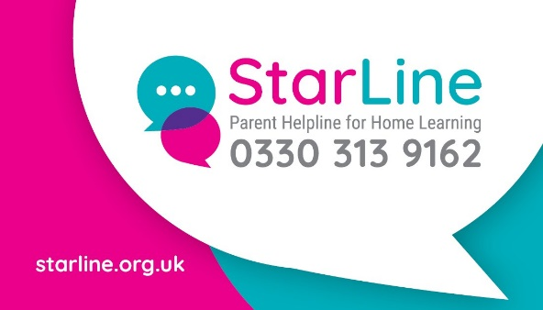

A new national free telephone helpline for parents and carers has been created to provide personalised support and advice on home learning to support pupils until schools re-open.
StarLine, a sector-led initiative supported by voluntary sector partners and the Department for Education, offers parents and carers personalised advice and support from a team of qualified teachers, education and parenting experts. Available to all parents and carers of school children nationwide, a team of education and parenting experts will share tips, techniques and resources to help young people continue their learning while schools are closed, and to support family wellbeing. Parents and carers will be guided to help their children create regular routines and study habits, offering practical steps to take and access to quality resources.
StarLine is open six days a week and covers all areas of the curriculum across all phases of education. In addition to qualified teachers, callers can speak to experienced education and parenting experts who can provide support and advice on behaviour, wellbeing and help for pupils with special educational needs or disabilities. All calls are confidential, and advice is available six days a week by phoning 0330 313 9162. For more information visit www.starline.org.uk

