Spag (spelling, punctuation & grammar) Mats explained.
- These can be done as part of Literacy.
- Each year group can access several mats. These start off with one star*(easier level) and work up. The answers are included.
- These do not need to be printed and can be
completed/recorded in books.
- To support with explanations of grammar, visit;
- IDL – familiar programme used at home https://idlsgroup.com/
- www.topmarks.co.uk/english-games/7-11-years/spelling-and-grammar
- www.bbc.co.uk/bitesize. Lots of videos
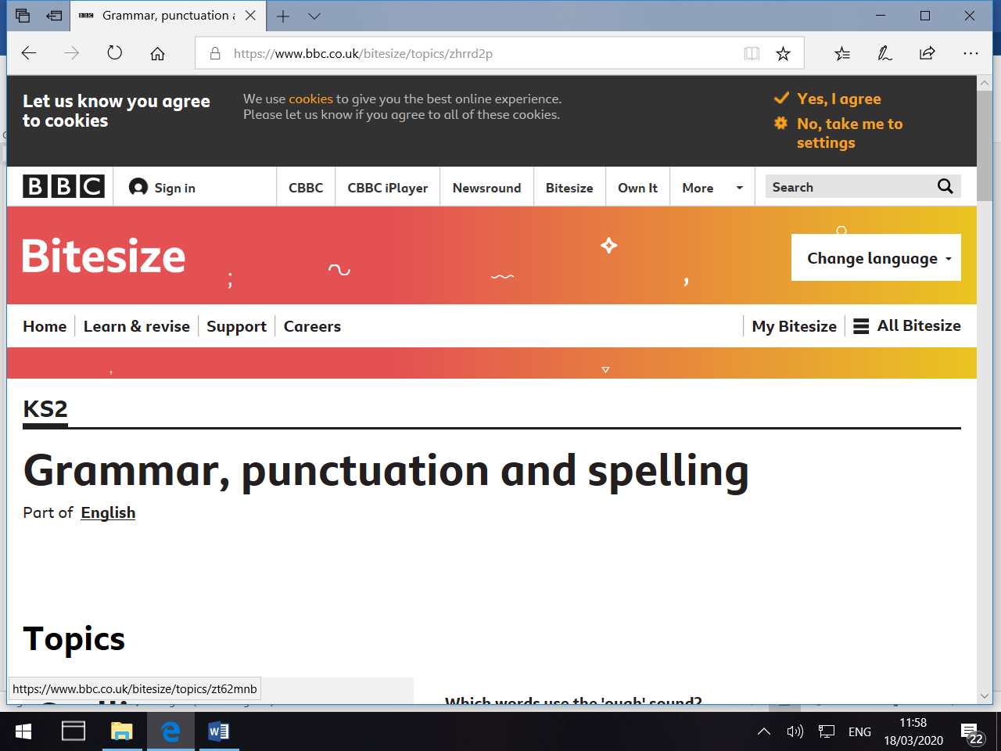
- The CGP books have explanations of grammar at the top and answers at the back. Each page has an explanation. Videos online and apps/games will support understanding.

These cover all areas of literacy to form part of a Literacy lesson to support you at home.
Further help and support online: Top 7 games.
www.teachwire.net/news/7-of-the-best-online-grammar-games-for-ks2
We love Comma castle. A great game to play independently
(we play in regularly in school) https://gridclub.com/activities/comma-castle

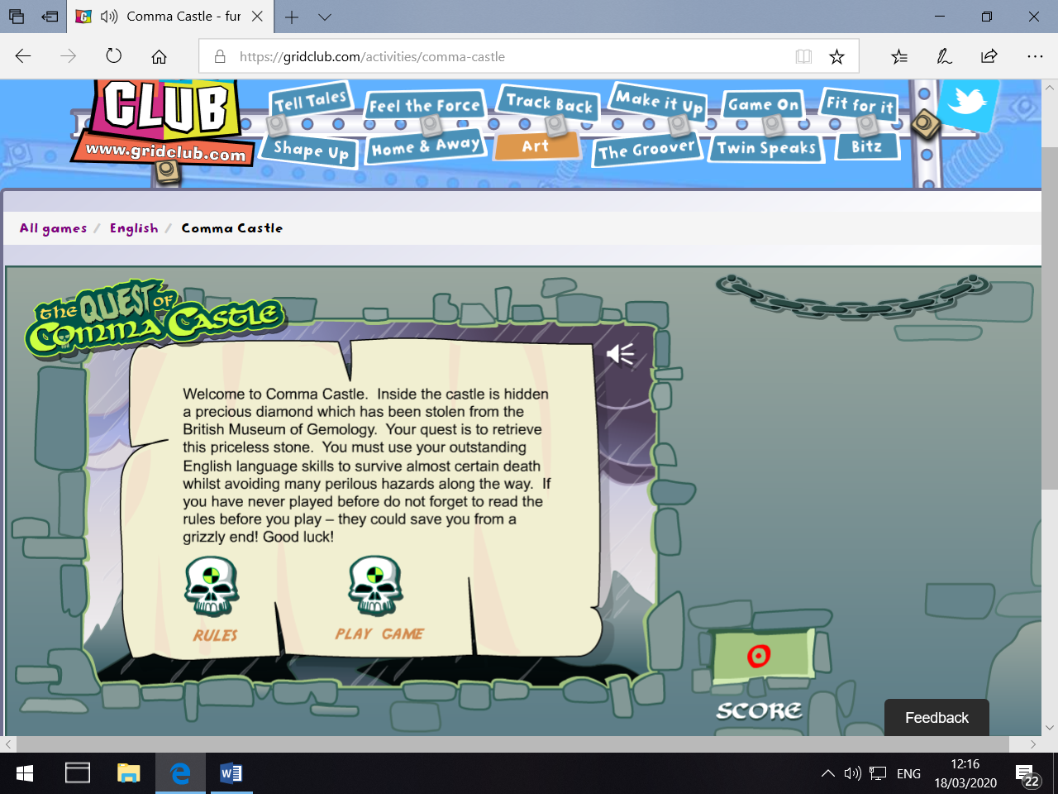
NOTE: I have not set spag.com work as the above work will support all levels of working alongside the GCP workbooks.

